3.5.1 Packet Tracer – Basic VLAN Configuration Answers
Topology
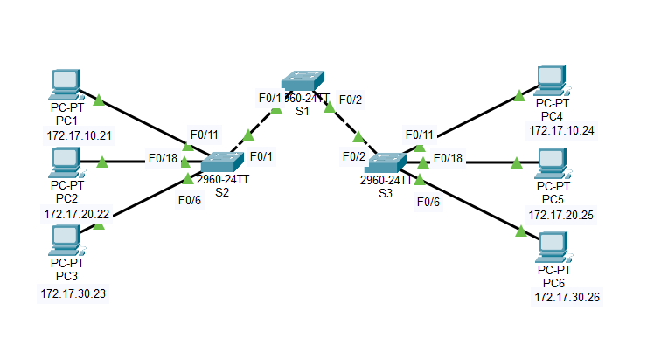
Addressing Table
Device | Interface | IP Address | Subnet Mask | Default Gateway
S1 | VLAN 99 | 172.17.99.11 | 255.255.255.0 | N/A
S2 | VLAN 99 | 172.17.99.12 | 255.255.255.0 | N/A
S3 | VLAN 99 | 172.17.99.13 | 255.255.255.0 | N/A
PC1 | NIC | 172.17.10.21 | 255.255.255.0 | 172.17.10.1
PC2 | NIC | 172.17.20.22 | 255.255.255.0 | 172.17.20.1
PC3 | NIC | 172.17.30.23 | 255.255.255.0 | 172.17.30.1
PC4 | NIC | 172.17.10.24 | 255.255.255.0 | 172.17.10.1
PC5 | NIC | 172.17.20.25 | 255.255.255.0 | 172.17.20.1
PC6 | NIC | 172.17.30.26 | 255.255.255.0 | 172.17.30.1
Port Assignments (Switches 2 and 3)
Ports | Assignment | Network
Fa0/1-0/5 | VLAN 99 – Management&Native | 172.17.99.0 /24
Fa06-0/10 | VLAN 30 – Guest(Default) | 172.17.30.0 /24
Fa0/11 – 0/17 | VLAN 10 – Faculty/Staff | 172.17.10.0 /24
Fa0/18 – 0/24 | VLAN 20 – Students | 172.17.20.0 /24

Learning Objectives
- Perform basic configuration tasks on a switch
- Create VLANs
- Assign switch ports to a VLAN
- Add, move, and change ports
- Verify VLAN configuration
- Enable trunking on inter-switch connections
- Verify trunk configuration
- Save the VLAN configuration

Task 1: Perform Basic Switch Configurations
Perform Basic Switch Configurations. Packet Tracer will only grade switch hostnames.
- Configure the switch hostnames.
- Disable DNS lookup.
- Configure an EXEC mode password of class.
- Configure a password of cisco for console connections.
- Configure a password of cisco for vty connections.
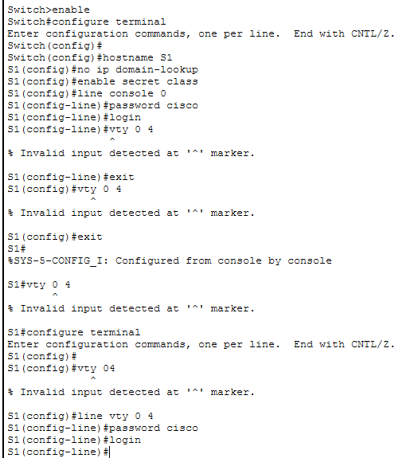

Task 2: Configure and Activate Ethernet Interfaces
Configure the Ethernet interfaces of the six PCs with the IP addresses and default gateways from the addressing table.
Note: The IP address for PC1 will be marked as wrong for now. You will change the PC1 IP address later.
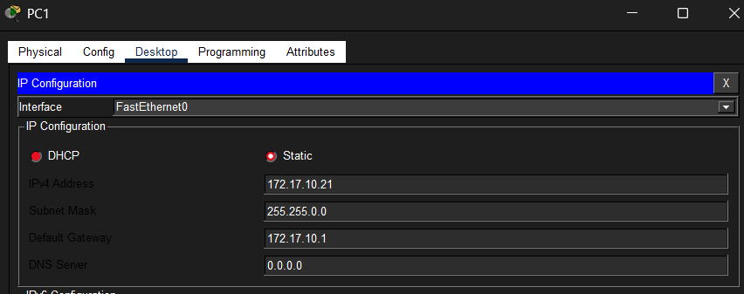
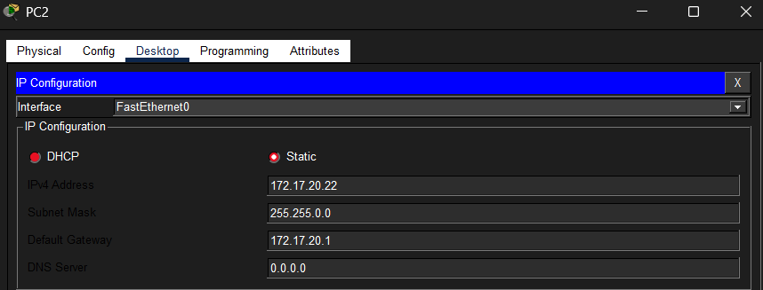
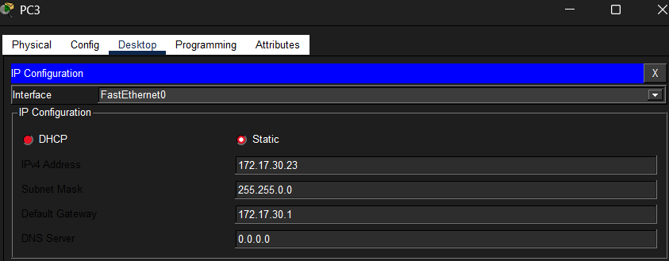
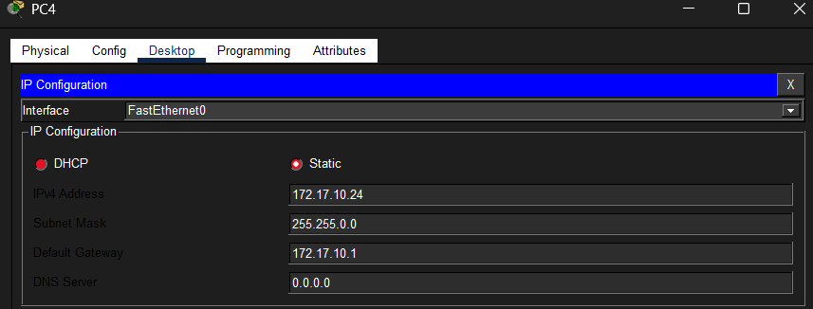
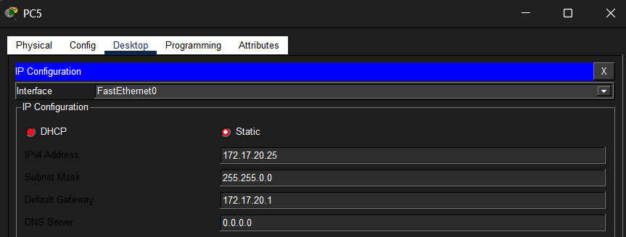
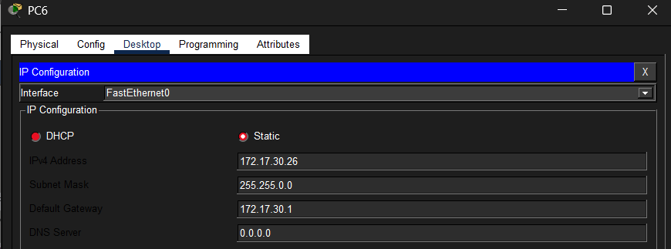
Task 3: Configure VLANs on the Switch
Step 1. Create VLANs on switch S1.
Use the vlan vlan-id command in global configuration mode to add VLANs to switch S1. There are four VLANs to configure for this activity. After you create the VLAN, you will be in vlan configuration mode, where you can assign a name to the VLAN with the vlan name command.
S1(config)#vlan 99
S1(config-vlan)#name Management&Native
S1(config-vlan)#exit
S1(config)#vlan 10
S1(config-vlan)#name Faculty/Staff
S1(config-vlan)#exit
S1(config)#vlan 20
S1(config-vlan)#name Students
S1(config-vlan)#exit
S1(config)#vlan 30
S1(config-vlan)#name Guest(Default)
S1(config-vlan)#exit
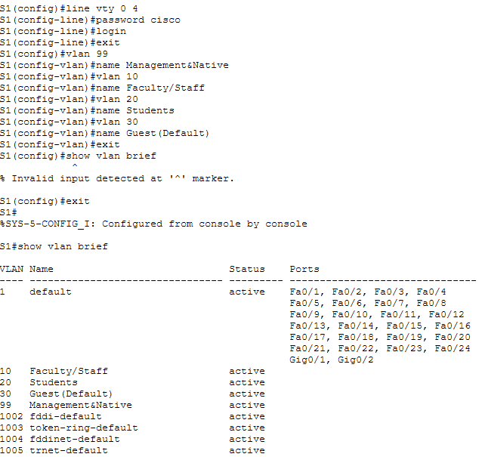

Step 2. Verify that the VLANs have been created on S1.
Use the show vlan brief command to verify that the VLANs have been created.
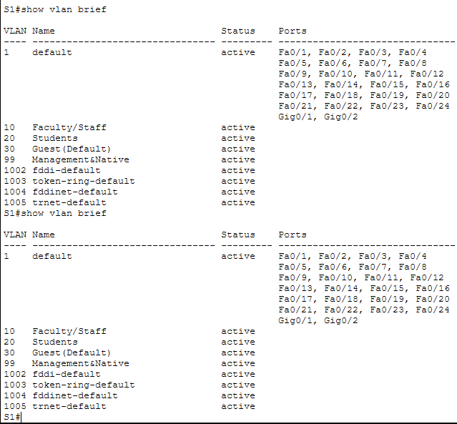

Step 3. Configure and name VLANs on switches S2 and S3.
Create and name VLANs 10, 20, 30, and 99 on S2 and S3 using the commands from Step 1. Verify the correct configuration with the show vlan brief command.
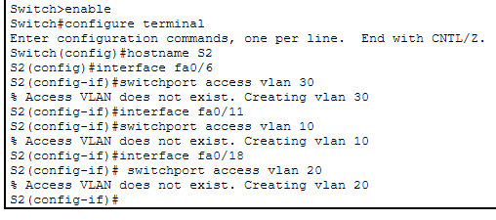
Figure 1: S2
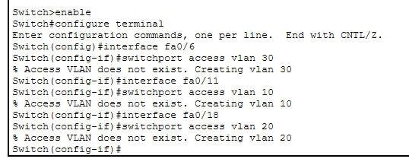
Figure 2:S3
What ports are currently assigned to the four VLANs you have created?
- VLAN 99 → Fa0/1–Fa0/5
- VLAN 30 → Fa0/6–Fa0/10
- VLAN 10 → Fa0/11–Fa0/17
- VLAN 20 → Fa0/18–Fa0/24

Step 4. Assign switch ports to VLANs on S2 and S3.
Refer to the port assignment table on page 1. Ports are assigned to VLANs in interface configuration mode, using the switchport access vlan vlan-id command. Packet Tracer will only grade the first interface in each range (the interface the PC is connected to). Normally you would use the interface range command, but Packet Tracer does not support this command.
S2(config)#interface fastEthernet0/6
S2(config-if)#switchport access vlan 30
S2(config-if)#interface fastEthernet0/11
S2(config-if)#switchport access vlan 10
S2(config-if)#interface fastEthernet0/18
S2(config-if)#switchport access vlan 20
S2(config-if)#end
S2#copy running-config startup-config
Note: The Fa0/11 access VLAN will be marked as wrong for now. You will correct this later in the activity.
Repeat the same commands on S3.
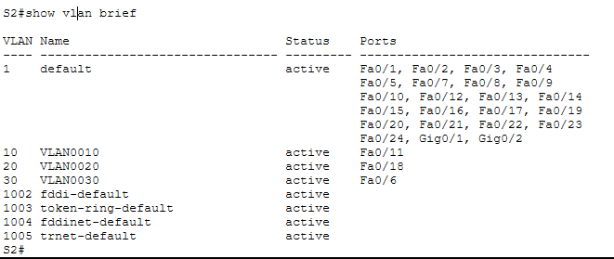
Figure 3: S2

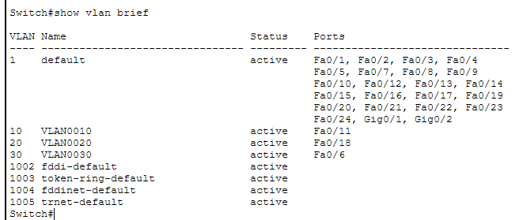
Figure 4: S3

Step 5. Determine which ports have been added.
Use the show vlan id vlan-number command on S2 to see which ports are assigned to VLAN 10.
Which ports are assigned to VLAN 10?
Fa0/11, Fa0/12, Fa0/13, Fa0/14, Fa0/15, Fa0/16, Fa0/17
Note: The show vlan name vlan-name displays the same output.
You can also view VLAN assignment information using the show interfaces switchport command.
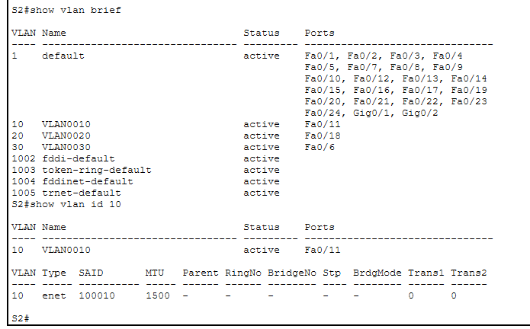
Step 6. Assign the management VLAN.
From interface configuration mode, use the ip address command to assign the management IP address to the switches.
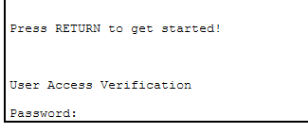

Step 7. Configure trunking and the native VLAN for the trunking ports on all switches.
Verify that the trunks have been configured with the show interface trunk command.

Step 8. Verify that the switches can communicate.
From S1, ping the management address on both S2 and S3.
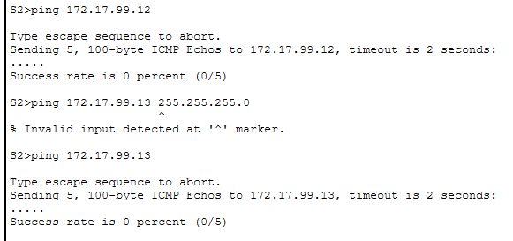
Step 9. Ping several hosts from PC2.
Ping from host PC2 to host PC1 (172.17.10.21). Is the ping attempt successful?
NO
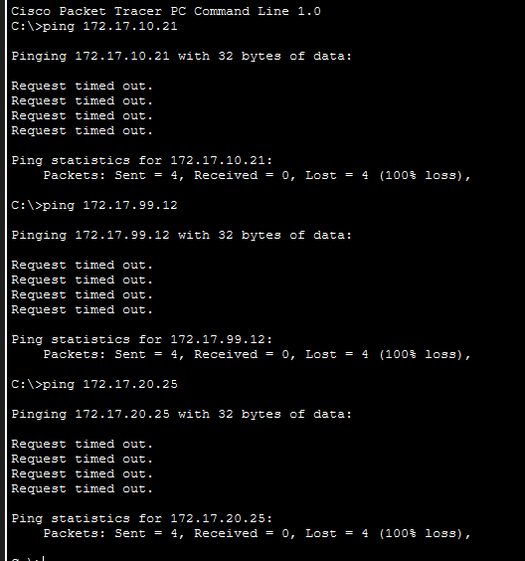
Ping from host PC2 to the switch VLAN 99 IP address 172.17.99.12. Is the ping attempt successful?
NO
Ping from host PC2 to host PC5. Is the ping attempt successful?
NO
Step 10. Move PC1 into the same VLAN as PC2. 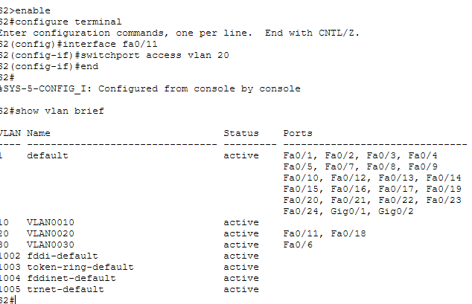
Ping from host PC2 to host PC1. Is the ping attempt successful?
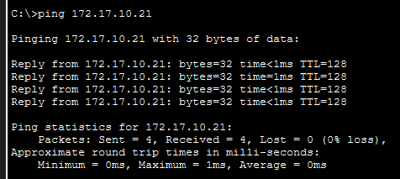
Step 11. Change the IP address and network on PC1.
Change the IP address on PC1 to 172.17.20.21. The subnet mask and default gateway can remain the same. Once again, ping from host PC2 to host PC1, using the newly assigned IP address.
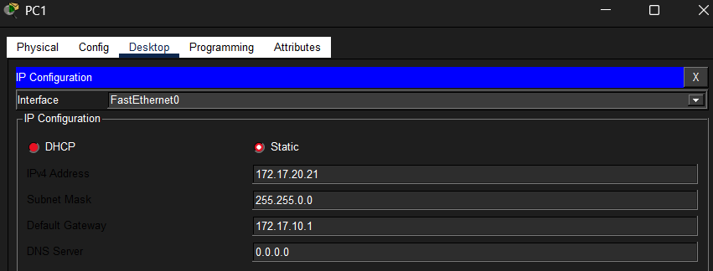
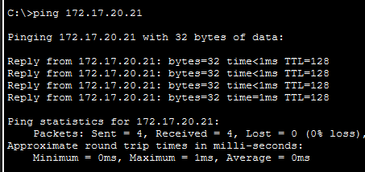
Is the ping attempt successful?
YES
Why was this attempt successful?
It was successful because once I moved PC1’s port into VLAN 20, I placed it in the same broadcast domain as PC2.

